

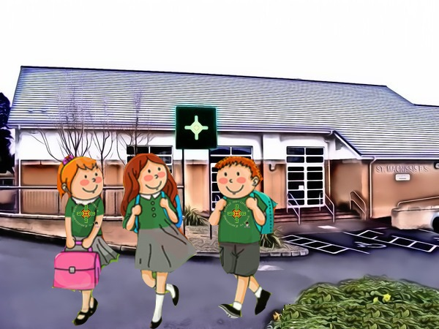

**Primary Two**

**Curriculum Overview**

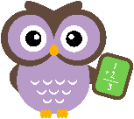

Literacy

**Reading**: Reading assessments are carried out during September to determine your child’s reading level. Reading materials will be sent home for your child to read and enjoy.

**Phonics**: Initially the focus will be on the revision of single letter sounds and blending these together. We will begin to look at digraphs when/if the children are ready.

**Writing Genre**: Narrative writing is the key focus this term. Pupils will identify the features of a narrative; title, character and setting.

**Handwriting** – letter

formation. Multi-sensory

activities to explore correct letter formation.

**Talking and Listening** underpins

all areas of learning and

your child will always be

encouraged to become involved

in Talking and Listening activities.

**Term 1**

Numeracy

**Mental Maths**

Counting forwards and backwards in 1s and 2s to 20.

**Number**

Consolidating understanding of numbers 1-20.

Identify numbers that come before after and in between a given number.

Exploring Odd and even numbers.

**Data Handling-**

Sorting into Venn and Carroll diagrams according to one criterion.

**Measure**

Your child will explore length through practical activities and will be able to order objects according to their length/height.

Know the days of the week and identify special times on the lock.

**Shape and Space**

Name common 3D shapes and explore the properties of common 3D shapes through play. Identify and name common 2D shapes**.**

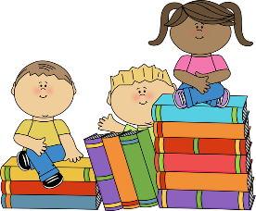

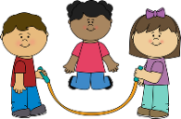

PE

P.E. will take place on a **Tuesday.**

**The World Around Us (Topic)**

Our first topic this term in Primary 2 is **All about me.** This will be extended to incorporate character and setting in relation to Narrative Writing.

We will begin our topic of **Fairy tales/Castles soon and Halloween** in October. The children will learn all about different fairy tales/traditions and their characteristics. They will explore what different properties materials have and how they can be joined. We will look at sounds in music and colours in art. The children will also learn about their local environment.

**Festive Fun** is our final theme this term where the children will be busy helping in the Christmas Post Office to ensure Santa receives all the letters from the boys and girls looking toys. They will write letters to Santa and will also explore money, counting and shape and space in the Role Play area.

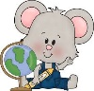



Homework

Your child will have homework each night (Monday – Thursday) and will have a different coloured folder each night. Homework may consist of Reading, spellings, a literacy task, Lexia, Numeracy task, Mathletics, Seesaw activity or Grow in love

\

ICT

Digital Storytelling – Film & Animation

****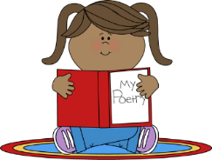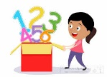****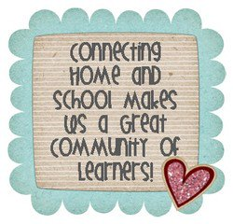

**Term 2**

Literacy

**Reading**: Continual reading assessments will be carried out with your child throughout the year to ascertain your child’s reading level. Reading materials will continue be sent home for your child to read. If your child can read fluently and their sight vocabulary is well developed short written comprehensions may accompany their reading books.

**Phonics**: The children will explore some digraphs and blends this term. Blending will focus on cvc, & cvcc words.

**Writing Genre**: Report writing is the key focus for the first half of this term. Pupils will identify the features of a report (title and a series of facts) and will relate this to our topic of People Who Help Us.

Following mid-term break the children will explore explanation texts through lifecycles and develop an understanding of the features associated with this writing genre.

.

Numeracy

**Mental Maths**

Counting forwards and backwards in 1s to 50, in 2s to 20, in 5s to 50 and in 10s to 100.

Mental subtraction within 10.

**Number**

The main focus this term will be on addition within 10 extended to 20 for those who are ready. Missing addends will be introduced.

Number stories for each number (1-10) will be explored.

Number doubles to 10 will also be a focus this term.

**Data Handling**

The children will explore data handling predominately through topic work this term sorting information such as eye colour, hair colour on pictograms and bar graphs.

**Measure**

Children will read o’clock times on the analogue and digital clock and will be introduced to half past times on both types of clocks.

**Shape and Space**

The children will explore the area of different surfaces through practical activities.

**The World Around Us (Topic)**

Our first topic this term will be **‘People Who Help Us’.** The children will learn all about the different people who help us in the local community. They will learn about their bodies and how to keep safe, fit and healthy. We will hopefully be able to arrange visitors from the local community to come in to school to talk to your children.

Our second topic this term is **‘The Farm’.** The children will learn all about farmers and their very important role in providing food for us. The children will learn about farm animals through the topic. We will also explore farm safety.

Useful Literacy games/ websites for your P2 child throughout the year:

[www.topmarks.co.uk/](http://www.topmarks.co.uk/)

www.communication4all.co.uk

[www.phonicsplay.co.uk](http://www.phonicsplay.co.uk)

<https://www.bbc.co.uk/bitesize/learn>

www.starfall.com

[www.youtube.com](http://www.youtube.com) – Alphablocks/Jolly Phonics Songs/



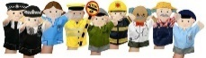

****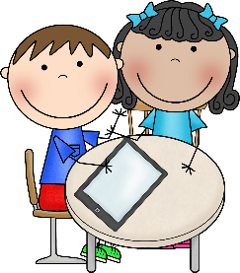

**Don’t forget to make use of all the activities in your resource pack and phonics activity booklet! ☺**

ICT

Digital Storytelling –Presenting

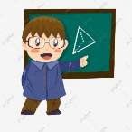

Literacy

**Reading**: Guided reading will continue in class and assessment in this area will be ongoing to ensure your child is reading material pitched at the correct level for them. Reading books will be sent home weekly.

**Phonics** The children will continue to explore the digraphs and work on cccvc words. We will work on developing their ‘fast reading’ skills and manipulating words by changing one sound.

**Writing Genre**: Poetry writing is the key focus this term. Pupils will explore an array of different poems; shape poems, acrostic poems, sensory poems and will have the opportunity to write some poetry of their own.

**Handwriting** – correct letter

formation and spacing continue to

be encouraged.

Numeracy

**Mental Maths**

Counting forwards and backwards in 1s to 50, in 2s to 20, in 5s to 50 and in 10s to 100.

Mental addition within 10.

**Number**

The main focus this term will be on subtraction within 10 extended to 20 for those who are ready.

Subtraction facts will be explored for each number (1-10)

Money within 20p – coin recognition/counting coins/adding and subtracting coins.

**Data Handling-**

The children will sort and extract information from pictograms and Carroll diagrams.

**Measure**

Capacity will be explored this term. The children will compare the capacity of an array of objects that differ in shape and size. They will use non-standard units to measure. This will build on the knowledge children have gained through play activities throughout the year.

**Shape and Space**

The children will explore turning movements (half turn, full turn) and will have the opportunity to use a computer controlled device to explore movement.

**Term 3**



**The World Around Us (Topic)**

This term we will be learning all about water throughout the topic **‘At the Seaside’.** We will be learning all about the different animals that live in the sea. We will name creatures and learn about how we can protect their natural habitats through reducing, reusing and recycling. Through science we will explore floating and sinking, and we will discuss the dangers associated with water. We will also explore the world of ‘pirates’ and immerse ourselves in pirate language and pirate role play. We will

finish our theme with a ‘Pirate Play Day’.

Useful Numeracy games/ websites for your P2 child throughout the year:

<http://www.topmarks.co.uk/>

www.starfall.com

[www.youtube.com](http://www.youtube.com) – Numberjacks/ Have Fun Teaching Songs.

[https://mathsframe.co.uk](https://mathsframe.co.uk/)

[www.coolmathgames.com](http://www.coolmathgames.com)

**Top Tip**

Make mental math activities fun for your child

- Count steps/ jumps/stairs

- Add numbers in environment







ICT

Digital Story Telling- Publishing

